LA MENNAIS SCHOOLS ACADEMIC COMMITTEE
BEGINNING OF TERM II EXAMINATIONS
P.7 INTEGRATED SCIENCE
Time allowed: 2 Hours 15 minutes

Name: ......................................................................................................................
School: ……………………………………..……….……Stream:……….……….
SECTION A
1. Name the body organ protected by the rib cage.
_____________________________________________________________________________________________
2. State the form of energy that changes water to vapour.
_____________________________________________________________________________________________
3. Identify one example of a saprophyte.
_____________________________________________________________________________________________
4. Write one way of controlling the spread of cholera in a home.
_____________________________________________________________________________________________
5. Mention any one animal fibre used for making clothes.
_____________________________________________________________________________________________
Below is a blood cell.
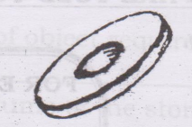

6. How important is a blood cell to the body?
_____________________________________________________________________________________________
_____________________________________________________________________________________________
7. Write one element of Primary Health Care (P.H.C).
_____________________________________________________________________________________________
8. State the functional difference between Ligaments and tendons.
_____________________________________________________________________________________________
_____________________________________________________________________________________________
9. What is the use of nasal hair in the nostrils of man?
_____________________________________________________________________________________________
10. State the food value we get from eating honey.
_____________________________________________________________________________________________
11. What name is given to the artificial habitat for fish?
_____________________________________________________________________________________________

12. How does one get infected with tape worms?
_____________________________________________________________________________________________
_____________________________________________________________________________________________
13. Give any one way in which wind can be used as an energy resource.
_____________________________________________________________________________________________
14. Why is the filament of an electric bulb coiled?
_____________________________________________________________________________________________
15. How best can a Primary Seven pupil avoid contracting STDs?
_____________________________________________________________________________________________
_____________________________________________________________________________________________
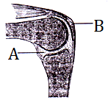
The diagram below shows a human joint. Study it and answer question 16 and 17.

16. Name the part marked B.
_____________________________________________________________________________________________
17. Give the function of part marked A.
_____________________________________________________________________________________________
_____________________________________________________________________________________________
18. Convert 50⁰F to ⁰C using the formula $\frac{5}{9}$ (⁰F – 32).

19. Mention any one rabbit disease.
_____________________________________________________________________________________________
20. Identify any one situation where filtration is applicable at home.
_____________________________________________________________________________________________
_____________________________________________________________________________________________
21. In which one way are bacteria useful to people?
_____________________________________________________________________________________________
_____________________________________________________________________________________________
22. State any one difference between chemical and physical change.
_____________________________________________________________________________________________ _____________________________________________________________________________________________
23. Suggest one way of changing the pitch of string musical instrument.
_____________________________________________________________________________________________
_____________________________________________________________________________________________
24. Why do you classify an Irish potato as a stem tube?
_____________________________________________________________________________________________
_____________________________________________________________________________________________
25. What is the end product of digestion of starch?
_____________________________________________________________________________________________
26. In the space below draw a compound leaf.

27. Briefly describe the first aid for burns and scald.
_____________________________________________________________________________________________
_____________________________________________________________________________________________
28. In which way can mulching be dangerous to crop farmers?
_____________________________________________________________________________________________
_____________________________________________________________________________________________
29. Name one example of arachnids.
_____________________________________________________________________________________________
30. State the function of the hydrochloric acid in the stomach during digestion.
_____________________________________________________________________________________________
_____________________________________________________________________________________________
31. In which state of matter does heat travel by convection?
_____________________________________________________________________________________________
The diagram below shows a foot of a bird.
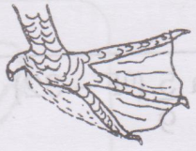

32. Which group of birds have the foot shown above?
_____________________________________________________________________________________________
33. State one danger of using hard paper in the modern toilet.
_____________________________________________________________________________________________
_____________________________________________________________________________________________
34. How can the government control the spread of cattle diseases in the districts?
_____________________________________________________________________________________________
35. The diagram below shows a magnet. Draw magnetic fields using a pencil.

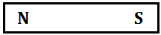

36. Give the method used to measure the volume of an irregular object.
_____________________________________________________________________________________________
37. Why does a school pupil need a water bottle?
_____________________________________________________________________________________________
_____________________________________________________________________________________________
38. Name the form of static electricity in nature.
_____________________________________________________________________________________________
39. Apart from living organisms and water, mention any other component of soil.
_____________________________________________________________________________________________
40. Alcohol is harmful to an individual. How is it important to man?
_____________________________________________________________________________________________
_____________________________________________________________________________________________

SECTION B

41. Match the sense organs to their uses correctly.
Sense Organ Use
eye smelling
nose seeing
skin tasting
tongue feeling
touching

(a) Eyes: _________________________________________________________________________
(b) Nose: _________________________________________________________________________
(c) Skin: _________________________________________________________________________
(d) Tongue: _________________________________________________________________________

42. (a) Give the difference between air and wind.
_____________________________________________________________________________________________
_____________________________________________________________________________________________
(b) State the importance of the following gases to man.
(i) Argon:
_____________________________________________________________________________________________
_____________________________________________________________________________________________
(ii) Carbon dioxide:
_____________________________________________________________________________________________
_____________________________________________________________________________________________
(c) Which property of air enables children to burst the balloons?
_____________________________________________________________________________________________
43. (a) What is pollination?
_____________________________________________________________________________________________
_____________________________________________________________________________________________
(b) Mention any one agent of pollination.
_____________________________________________________________________________________________
(c) Give a reason why paw paws avoid self-pollination.
_____________________________________________________________________________________________
_____________________________________________________________________________________________
(d) Give one importance of pollination to plants.
_____________________________________________________________________________________________
_____________________________________________________________________________________________
44. (a) Write one sentence to show the meaning of immunity.
_____________________________________________________________________________________________
(b) Identify the type of immunity acquired through;
(i) Injecting vaccines into the body.
_____________________________________________________________________________________________
(ii) Suffering and recovering from an illness.
_____________________________________________________________________________________________
(d) State the best way of controlling immunisable diseases in babies.
_____________________________________________________________________________________________
_____________________________________________________________________________________________
45. (a) One of the factors that make a torch fail to work is poor arrangement of batteries. In the space below, draw and arrange the batteries correctly.
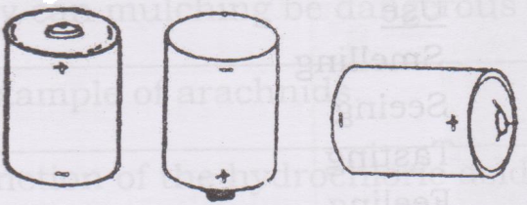

(b) What energy change takes place in the dry cells when the circuit is complete?
__________________________________________________________________________________________________________________________________________________________________________________________
(c) Mention one cause of short circuit.
__________________________________________________________________________________________________________________________________________________________________________________________
(d) Give one way of preventing dangers caused by short circuit.
__________________________________________________________________________________________________________________________________________________________________________________________
46. (a) Give one importance of a good posture.
__________________________________________________________________________________________________________________________________________________________________________________________
(b) What mineral is needed for the formation of strong bones?
_____________________________________________________________________________________________
(c) Mention one disease and disorder of the skeletal system;
(i) Disease: ________________________________________________________________________________
(ii) Disorder: ______________________________________________________________________________
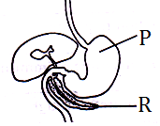
47. The diagram below shows parts of the alimentary canal of man. Use it to answer the question about it.

(a) Name the part marked.
(i) P ________________________________________________________________________________________
(ii) R _______________________________________________________________________________________
(b) Identify the digestive juice produced at part marked P.
_____________________________________________________________________________________________
(c) Mention one disorder of the above system.
__________________________________________________________________________________________________________________________________________________________________________________________
48. (a) Give the difference between vectors and germs.
__________________________________________________________________________________________________________________________________________________________________________________________
(b) Mention one common vector that breeds in still water.
_____________________________________________________________________________________________
(c) How does pouring oil on still water prevent the spread of malaria?
_____________________________________________________________________________________________
_____________________________________________________________________________________________
(d) Suggest any other danger of malaria to our lives.
__________________________________________________________________________________________________________________________________________________________________________________________
49. (a) Name any two traditional method used in preserving food.
(i) __________________________________________________________________________________________
(ii) _________________________________________________________________________________________

(b) Give two reasons of preserving food.
(i) __________________________________________________________________________________________
(ii) _________________________________________________________________________________________
50. The diagram below shows parts of a flower.
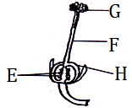

(a) Name the parts marked.
(i) F ________________________________________________________________________________________
(ii) H _______________________________________________________________________________________
(b) What process takes place at G?
_____________________________________________________________________________________________
(c) What does part E develop into after fertilization?
_____________________________________________________________________________________________
51. (a) Why do farmers keep the following types of chicken?
(i) Table birds: ___________________________________________________________________________
_____________________________________________________________________________________________
(ii) Light birds: ___________________________________________________________________________
_____________________________________________________________________________________________
(b) Which type of food is given to the types of chicken mentioned in (a) above?
(i) Table birds: ____________________________________________________________________________
(ii) Light birds: ___________________________________________________________________________
52. (a) Explain the following terms as used during the study of reproduction.
(i) Adolescence: __________________________________________________________________________
_____________________________________________________________________________________________
(i) Puberty: _______________________________________________________________________________
_____________________________________________________________________________________________
(b) Where does conception take place in man?
_____________________________________________________________________________________________
(c) What is the duration of the gestation period of a human being?
_____________________________________________________________________________________________
53. (a) Name the two types of germination.
(i) __________________________________________________________________________________________
(ii) _________________________________________________________________________________________
(b) How are the following conditions important during germination?
(i) Water: __________________________________________________________________________________
_____________________________________________________________________________________________
(ii) Oxygen: _______________________________________________________________________________
_____________________________________________________________________________________________
54. The diagram below shows a method of finding volume of certain objects. Use it to answer questions that follow.
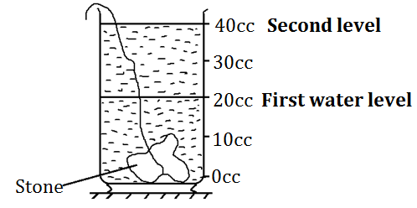

(a) What kind of object requires the above method of finding volume?
__________________________________________________________________________________________________________________________________________________________________________________________
(b) Find the volume of the stone above.

(c) If the mass of the stone is 60gms. Calculate its density. (2mks)

55. (a) Name one example of an energy resource in environment.
_____________________________________________________________________________________________
(b) Identify the energy resource that is used in production of solar energy.
_____________________________________________________________________________________________
(c) Give one advantage of using parabolic solar cookers.
__________________________________________________________________________________________________________________________________________________________________________________________
(d) Mention one disadvantage of parabolic solar cookers.
__________________________________________________________________________________________________________________________________________________________________________________________

*****GOD BLESS*****

